Users of the Headquarters (HQ) instance of RiskVision have recently been experiencing login failures due to Active Directory domain controller issues. The application administrator has implemented an alternate login process in the event there are future issues with the domain controllers. Effectively immediately, users of the Headquarters instance of RiskVision may now choose between new, different “domains” for authentication when logging into RiskVision. The new “domains” presently consist of VA.Gov2 through 4 as shown in example 1.a below, with more to be added.

It is important to note the domain listed in the dropdown is not related to the users account domain. Any one of the choices is suitable for any user in the VA regardless of location.

When unsuccessful authentication is experienced and users are certain their login and password are correct, it is recommend users select the first VA.Gov option and proceed through the VA.Gov2, etc. choices until login is successful.

**Specific Instructions:**

1. **Login ID:** Users have the option of using their qualified alias, alias or email address (UPN) to log into RiskVision.
   1. [domain]\[alias] (aka LAN/Windows login) – see example 1.a below
   2. Alias (aka LAN/Windows login) – see example 1.b below
   3. Email address – see example 1.c below
2. **Password:** LANWindows password
3. **Domain:** Select any choice (recommend starting at the top of the list) – If the user does not select one of the choices, the login will fail.
4. **Login:** Click on the login button to complete login.

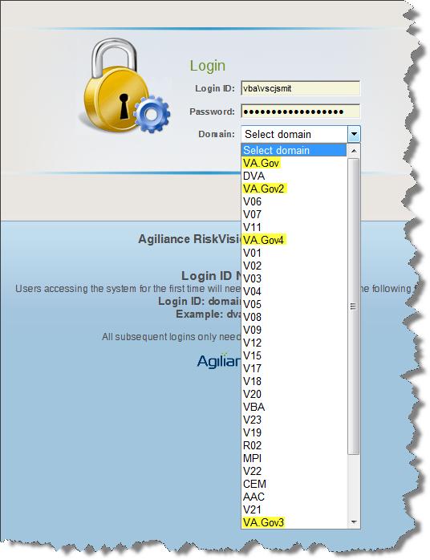

Example 1.a

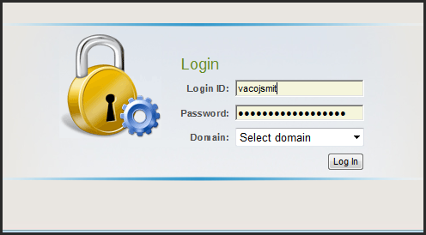

Example 1.b

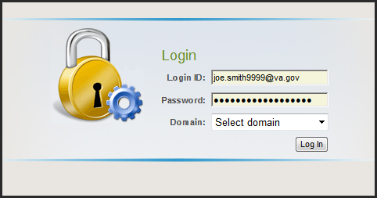

Example 1.c